1.Write a java program to create generatic method the take list of numbers and return the sum of all the even and odd number?

CODE:

import java.util.List;

public class NumberSumCalculator {

public static <T extends Number> int[] calculateSum(List<T> numbers) {

int sumEven = 0;

int sumOdd = 0;

for (T number : numbers) {

if (number.intValue() % 2 == 0) {

sumEven += number.intValue();

} else {

sumOdd += number.intValue();

}

}

return new int[]{sumEven, sumOdd};

}

public static void main(String[] args) {

List<Integer> numbers = List.of(1, 2, 3, 4, 5, 6, 7, 8, 9, 10);

int[] sums = calculateSum(numbers);

System.out.println("Sum of Even Numbers: " + sums[0]);

System.out.println("Sum of Odd Numbers: " + sums[1]);

}

}

OUTPUT:

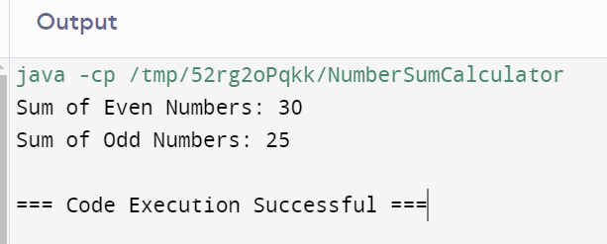

2. Write a java program t0 create generatic method thaT take a list of any types and a target element it return the index of first occurance of the target element in the list AND return -1 if the targtet element cannot be found?

CODE:

import java.util.List;

public class Main {

public static void main(String[] args) {

List<Integer> numbers = List.of(1, 2, 3, 4, 5, 6, 7, 8, 9, 10);

System.out.println("Index of 5: " + indexOf(numbers, 5));

System.out.println("Index of 15: " + indexOf(numbers, 15));

List<String> strings = List.of("apple", "banana", "cherry", "date", "elderberr");

System.out.println("Index of \"cherry\": " + indexOf(strings, "cherry"));

System.out.println("Index of \"fig\": " + indexOf(strings, "fig"));

}

public static <T> int indexOf(List<T> list, T target) {

for (int i = 0; i < list.size(); i++) {

if (list.get(i).equals(target)) {

return i;

}

}

return -1;

}

}

OUTPUT:

